Performance Analysis of CPU Scheduling Algorithms (FCFS, SRTF, RR) for Audio-Video Systems

1. Introduction

1.1 Background
In modern operating systems, the CPU schedular is responsible for determining the order and duration of process execution. While traditional batch processing systems prioritize overall throughput, multimedia applications, such as audio and video systems. These systems require strict timing guarantees to prevent buffer underruns (which cause audio stuttering) and dropped frames (which cause video lag). Therefore, the choice of CPU scheduling algorithm directly impacts the user experience in media centric environments.

1.2 Related Work
Foundational operating systems literature, such as (Silberschatz, et al., 2018) establishes that non-pre-emptive algorithms like First-Come, First-Served (FCFS) often suffer from the “convoy effect” where short processes are delayed by long ones. Conversely, pre-emptive algorithms like Shortest Remaining Time First (SRTF) and Round Robin (RR) are designed to mitigate these delays. (Stallings, 2018) notes that while SRTF optimizes waiting times, RR provides superior fairness and predictable response times, making it a frequent choice for interactive and time sensitive systems.

1.3 Problem Statement
Inefficient CPU scheduling in audio and video systems leads to high response times, causing perceptible lag and poor user experience. As the number of concurrent background and foreground processes increases, the performance difference between scheduling algorithms become more noticeable. There is a need to empirically determine which algorithm best handles increasing process loads.

1.4 Aim and Objectives
Aim: To develop a simulator comparing FCFS, SRTF, and RR under increasing process loads.
Objectives:
- Generate workloads from 10 to 50 processes,
- Measure WT, TAT, RT, Throughput, and CPU Utilization
- Identify the optimal algorithm for audio and video systems environments

1.5 Significance of the Project
This project provides empirical data to help OS developers, and audio and video software engineers choose the most appropriate scheduling policy. By understanding how algorithms behave under load, developers can better configure system priorities to guarantee smooth, uninterrupted media rendering and playback.

2. Methodology

2.1 Tools Used
The simulator was developed using Python 3.13.15 chosen for it’s robust data handling capabilities. The dataclasses module was used for structured process modelling. Matplotlib was utilized for data visualization and graphical trend analysis, while the built-in csv module was used for raw data logging.

2.2 Simulator Flow Diagram
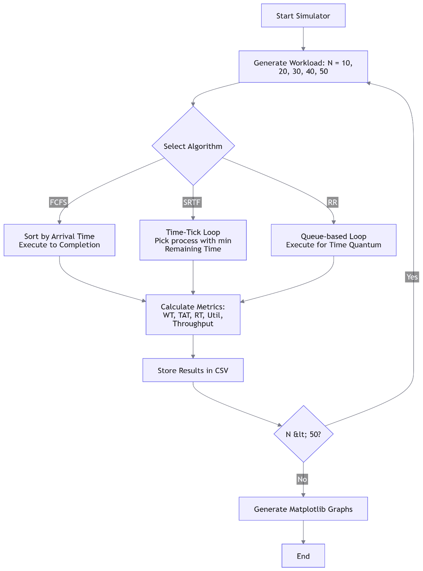

2.3 Algorithms Defined
- First-Come, First-Served (FCFS): A non-pre-emptive algorithm where processes are executed strictly in the order of their arrival time.
- Shortest Remaining Time First (SRTF): A pre-emptive version of Shortest Job First. The CPU is allocated to the process with the smallest remaining execution time. If a new process arrives with a shorter remaining time than the currently executing process, pre-emption occurs.
- Round Robin (RR): A pre-emptive time-slicing algorithm. Each process is assigned a random time quantum. If a process does not complete within its quantum, it is pre-empted and placed at the back of the ready queue.
Clarification on Algorithm Selection: The projects brief mentions ”Pre-emptive Priority Scheduling” but explicitly lists FCFS, SRTF and RR for comparison. In alignment with the standard Operating System principles, this simulator implements the three explicitly listed algorithms. The ‘Priority’ attribute is generated for each process to maintain data structure completeness ‘Time Quantum’ expiration, as per their canonical definitions.

2.4 Performance Metrics and Formulae
List the 5 formulas clearly.
- Turnaround Time = Completion Time - Arrival Time
- Waiting Time = Turnaround Time - Burst Time
- Response Time = First Execution Time - Arrival Time
- CPU Utilization = (Total Busy Time / Total Elapsed Time) × 100
- Throughput = Total Processes Completed / Total Elapsed Time

2.5 Data Collection Methods
This project utilizes a Quantitative Method. Numerical performance data is collected empirically through controlled, repeatable software simulation (using a fixed random seed for reproducibility).

2.6 Data Analysis Tool
Python matplotlib is used to perform comparative trend analysis, plotting metrics against increasing process counts to determine statistical superiority.

3. Results and Analysis
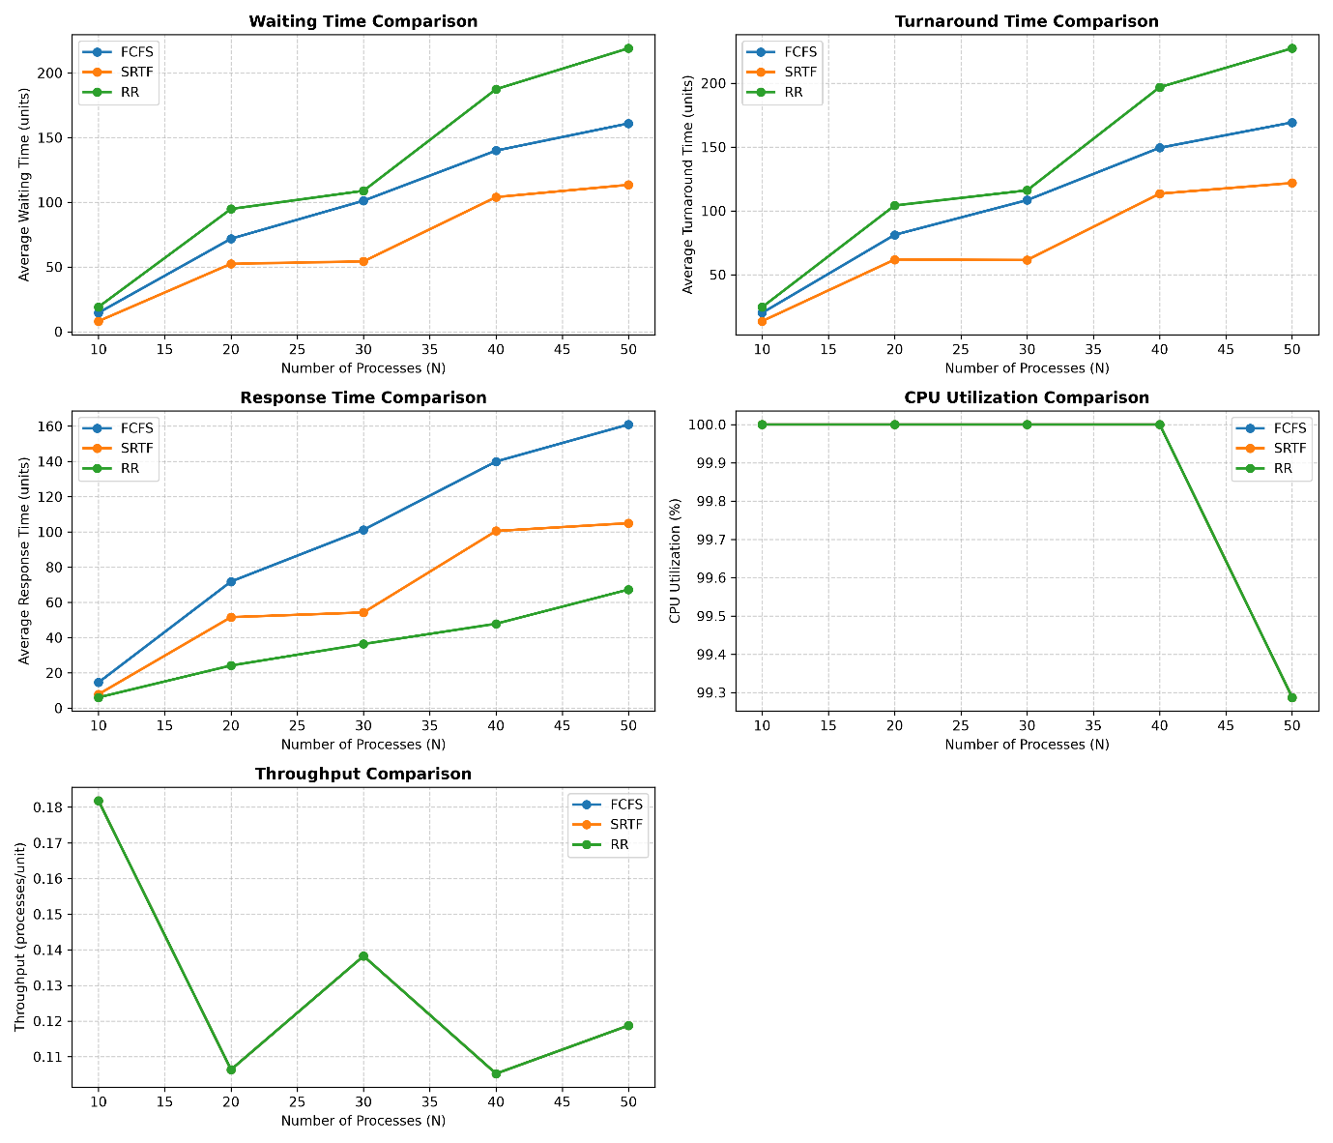
3.1 Waiting Time Analysis: "As shown in Figure 1, as processes increase to 50, SRTF maintains the lowest average waiting time..."
3.2 Turnaround Time Analysis: "Figure 2 demonstrates..."
3.3 Response Time Analysis: "Figure 3 highlights that Round Robin and SRTF significantly outperform FCFS in response time..."
3.4 Throughput & CPU Utilization Analysis: "Figures 4 and 5 show..."

4. Discussion

4.1 Findings on Performance Metrics
Directly answer the 5 investigative questions from the prompt. (e.g., "SRTF minimizes waiting time and gives the best turnaround time. RR demonstrates highly competitive response time...").

4.2 Strengths and Weaknesses
FCFS: Strength: Simple, low overhead. Weakness: Convoy effect, high response time.
SRTF: Strength: Optimal waiting/turnaround time. Weakness: Starvation of long processes, high context-switch overhead if not managed.
RR: Strength: Excellent fairness and predictable response time. Weakness: Throughput drops if time quantum is too small (excessive context switching).

4.3 Area of Application
Explicitly state: "For Audio-and-Video systems, Round Robin (with a tuned time quantum) or SRTF is the best-performing algorithm. A/V systems prioritize low Response Time to ensure immediate playback initiation and prevent buffer starvation, which RR and SRTF provide, unlike FCFS."

5. Conclusion
Summarize the aim, the method (simulating 10-50 processes), and the final verdict (e.g., SRTF/RR is best for A/V). State that the simulator successfully met all objectives.

6. References
Arpaci-Dusseau, R. H. & Arpaci-Dusseau, A. C., 2018. Operating Systems: Three Easy Pieces. s.l.:CreateSpace Independent Publishing Platform.
Silberschatz, A., Galvin, P. B. & Gagne, G., 2018. Operating System Concepts. 10 ed. s.l.:Wiley.
Stallings, W., 2018. Operating Systems: Internals and Design Principles. 9 ed. s.l.:Pearson.

Appendix
Mention: "Raw simulation data is provided in report/simulation_data.csv and source code is attached."

